In this assignment you will work in groups of two in order to implement an extension of Legends: Monsters and Heroes called Legends of Valor.
This time the heroes battle monsters in a contest of strategy and skill. Take advantage of the terrain, coordinate actions between heroes, and use items to outwit and outfight the invading waves of monsters. Can your heroes destroy the monsters’ Nexus and stop the monster invasion? Or will the monsters overrun your own fortress?

Overview
Legends of Valor is a MOBA (multiplayer online battle arena)-like game. The player will control a team of 3 heroes who will attempt to fight their way through to the monsters’ Nexus. The heroes win if any of them reach the monsters’ Nexus. The heroes lose if any monster reaches the heroes’ Nexus.
Many aspects of Legends of Valor are carried over from Monsters and Heroes. Items, heroes, and monsters are the same. The calculations for damage and armor remain the same. Experience and gold are given on a per-monster basis, but the amounts per monster are the same as before.

The World of Play
Legends of Valor is played in an 8x8 grid of spaces. The grid is divided in three lanes, each separated by a column of impassible spaces. Each lane has a width of two spaces. Each space can hold up to one monster and up to one hero. A space cannot hold two monsters or two heroes.
The first two columns are the first (top) lane. The third column is a wall between the first and the second lane. The fourth and the fifth columns are the second (middle) lane. The sixth column is another wall. The seventh and eighth columns are the third (bottom) lane. The first and the last row will represent a Nexus. The first row (at the top of the screen) is the monsters’ Nexus while the last row (at the bottom of the screen) is the heroes’ Nexus. See the layout below:

Top Lane |  |  | Mid Lane |  |  | Bot Lane

Monsters’ Nexus
Heroes’ Nexus

Note that the walls separate the Nexus spaces in each lane.
Spaces differ between Legends of Valor and Monsters and Heroes. Legends of Valor introduces spaces with terrain bonuses and new behaviors. The spaces used in Legends of Valor are:
- Nexus
- Inaccessible
- Obstacle
- Plain
- Bush
- Cave
- Koulou
Nexus. The spaces at the top and bottom of each lane are the Nexus spaces. Monsters and heroes spawn at their respective Nexus. The heroes’ Nexus also serves as a market, where heroes can buy and sell items. Reaching an opponent’s Nexus space ends the game.
Inaccessible. Heroes and monsters cannot enter these spaces.
Obstacle. Heroes and monsters cannot enter this space. However, a hero can use a turn to remove the obstacle. When removed, the obstacle space becomes a plain space.
Plain. These spaces have no special attributes.
Bush. Bush spaces increase the dexterity of any hero inside them. The bonus is removed when the hero leaves the space. For a more challenging game, monsters can also receive a bonus in this space.
Cave. Cave spaces increase the agility of any hero inside them. The bonus is removed when the hero leaves the space. For a more challenging game, monsters can receive a dodge bonus in this space.
Koulou. Koulou spaces increase the strength of any hero who is inside them. The bonus is removed when the hero leaves the space. For a more challenging game, monsters can receive an attack bonus in this space.
The obstacles, plain, bush, cave, and koulou spaces are randomly distributed in the lanes. This does not change the placement of Nexus and Inaccessible cells, which should exist as described above. You are encouraged to experiment with any type distribution you find that makes the game interesting as long as:
- the board has special spaces of each type, • the board is not entirely special spaces, and
- the distribution is random.

Gameplay
The game is played by two teams: a team of 3 heroes and a team of monsters. The player will control the hero team. The game itself will control the monsters.
The goal of each team is to have one of their members reach the Nexus of the other team.
Before the game begins, the player chooses the three heroes that will be used and which of the three lanes that hero will start in. At the start of the game the heroes spawn in their Nexus and three equally-leveled monsters spawn in their Nexus. The Nexus space that a hero spawns in is specific to that hero, and that relationship is maintained for the whole game.
The game is played in rounds. A round consists of the heroes’ turn followed by the monsters’ turn. During the heroes’ turn, the player must perform one valid action for each of the heroes. Once all of the heroes have made their move, their turn is over. Then it becomes the monsters’ turn. During the monster’s turn each monster either attacks a hero (if they meet the conditions to attack) or moves one space “forward” (towards the heroes’ Nexus). Once all of the monsters on the board have acted, the round is over and a new round begins.
The following are actions which can be taken by a hero in Legends of Valor:
- Change Weapon or Armor
- Use a Potion
- Attack
- Cast a Spell
- Move
- Teleport
- Recall
Change weapon or armor. This action functions identically to the equip weapon or armor action in Monsters and Heroes: A hero will equip the selected weapon or armor piece and end their turn.
Use a Potion. This action functions identically to the use a potion action in Monsters and Heroes: A hero will consume the potion and receive its effects. Then that hero’s turn ends.
Attack. The attack move’s damage is calculated the same as in Monsters and Heroes. However, we must now consider whether an enemy is within range to attack. The attack range is limited to the current space and its neighbors (see diagram for the mid lane below).
Inaccessible | Out-of-range | Out-of-range | Inaccessible
Inaccessible | In-range | In-range | Inaccessible
Inaccessible | In-range | Current space | Inaccessible
Inaccessible | In-range | In-range | Inaccessible
Inaccessible | Out-of-range | Out-of-range | Inaccessible
A hero can only attack one monster per turn, even if multiple are in range. The same applies for monsters.
Cast a Spell. The spell damage and effect are the same as in Monsters and Heroes. The range limitation for the attack move also applies for spell moves in Legends of Valor.
Move. The move action allows a hero or a monster to move north, west, south, or east. There is no diagonal movement. Each hero or monster moves separately from the others. Legends of Valor adds additional rules that a hero cannot move behind a monster without killing it and a hero cannot move into a space already occupied by another hero. See diagram below demonstrating different scenarios for the hero’s move in the top lane:
   | Monster | Inaccessible
  Illegal move | Legal move | Inaccessible
  Legal move | Hero | Inaccessible
  Illegal move | Legal move | Inaccessible
   |  | Inaccessible
  Illegal Move | Illegal Move | Inaccessible
  Monster  Legal Move | Hero | Inaccessible
  Illegal move | Legal Move | Inaccessible

   |  | Inaccessible
  Illegal move | Monster Legal move | Inaccessible
  Legal move | Hero | Inaccessible
  Illegal move | Legal move | Inaccessible
   |  | Inaccessible
  Illegal Move | Illegal Move | Inaccessible
  Legal Move | Monster Hero | Inaccessible
  Illegal move | Legal Move | Inaccessible

  Illegal move | Monster Legal move | Inaccessible
  Hero  Illegal move | Hero | Inaccessible
  Illegal move | Legal move | Inaccessible
  Illegal Move | Hero  Illegal Move | Inaccessible
  Legal Move | Hero | Inaccessible
  Illegal move | Legal Move | Inaccessible
This rule also applies for monsters. Thus, by skillful placement, a hero may block a monster from reaching the Nexus until that hero is killed.
Teleport. A teleport action allows a hero to move to a space adjacent to a target hero in a different lane. Teleport works only between different lanes, so a hero cannot teleport from one space in a lane to another space in the same lane. A hero may not teleport to a space ahead of the hero being teleported to, onto a space already occupied by another hero, and not behind a monster in the lane. See the diagram below, where a hero in the top lane is teleporting to a hero in the bottom lane:

Inaccessible | Illegal move | Illegal move |  | Inaccessible | Illegal move | Illegal move
Inaccessible | Target Hero | Legal move |  | Inaccessible | Target Hero | Monster Legal move
Inaccessible | Legal move | Illegal move |  | Inaccessible | Legal move | Illegal move

Inaccessible | Illegal move | Illegal move
Inaccessible | Target Hero | Hero  Illegal move
Inaccessible | Legal move | Illegal move

Recall. The recall action allows a hero to return to their specific Nexus. This will always return the hero to the Nexus space they spawned at—no matter how far they are from that Nexus space (i.e. even if the hero is in another lane).
You may add a “pass turn” action if you feel it improves gameplay.
Heroes and monsters make one valid move per turn. Buying and selling do not count as actions so a hero can, for example, buy two items, sell one, and then make a move in a single turn.
Similar to Monsters and Heroes, at the end of every round every hero that is still alive regains 10% of their hp and 10% of their mana. When a hero dies, they respawn in their specific Nexus space at the start of the next round.
Every few rounds, three new monsters will spawn in the monsters’ Nexus, one for each lane.
You can implement a game difficulty that specifies how frequently a new monster is spawned (for example, easy: new spawn every 6 rounds, medium: every 4 rounds, hard: every 2 rounds). Therefore, at any given time, each lane can contain multiple monsters if the hero does not kill the current monster before the next one spawns!

Examples and Suggestions

- The board is composed of 20% of each special space type (Bush, Cave, and Koulou) and 40% Plain spaces
- The special spaces increase the hero’s stat by 10% (i.e. A Bush space increases a hero’s dexterity by 10%)
- Monsters drop 500 × 𝑚𝑜𝑛𝑠𝑡𝑒𝑟_𝑙𝑒𝑣𝑒𝑙 gold when killed, given to all heroes
- Monsters give 2 ∗𝑚𝑜𝑛𝑠𝑡𝑒𝑟_𝑙𝑒𝑣𝑒𝑙 experience points when killed, given to all heroes
- Monsters do not receive terrain bonuses
- Heroes spawn in the left space of their lane’s Nexus
- Monsters spawn in the right space of their lane’s Nexus
- Monsters attack if any hero is within attack range
- Monsters only move down (south)
- New monsters spawn every 8 rounds
- New monsters have a level equal to highest level among the 3 heroes
- Heroes respawn with full HP and full MP and lose no gold for dying
- Victory for a team happens immediately upon entry of any enemy Nexus space by a team member

Example terminal visual representation:
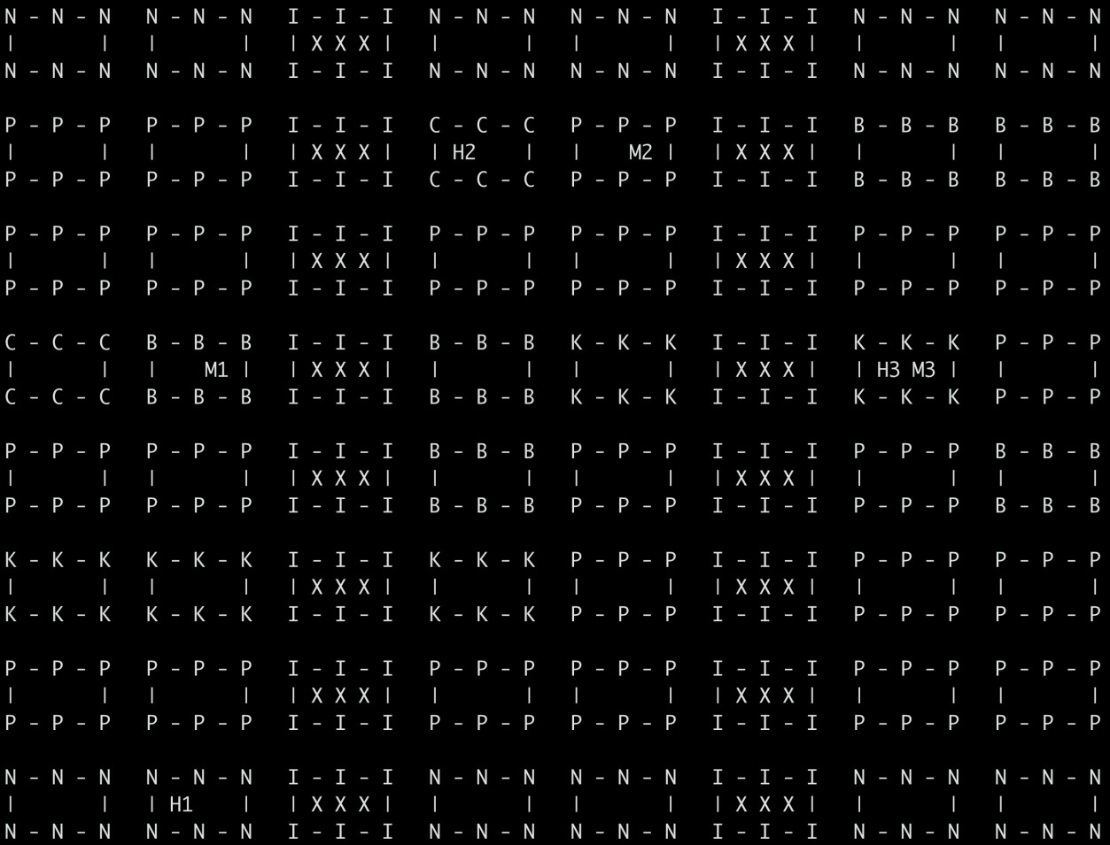
The three heroes are represented as H1, H2, and H3. The monsters are correspondingly M1, M2, and M3. Note that both a hero and a monster can occupy a space together. Your interface should be able to represent the same. The space types are denoted by:
- N – Nexus
- I – Impassible
- P – Plain
- C – Cave
- B – Bush
- K – Koulou

There are three main goals to this assignment:
- Gain experience effectively developing software in a team.
- Learn to analyze structures and learn from programs that are not your own.
- Learn how to develop reusable code and how to actually reuse existing codebases.
In order to have as effective communication as possible (which will likely prove useful in your future), for this assignment we strongly suggest the use of git and Slack. There will be a quick demo of both tools by the TA and, further assistance in their basic usage can be offered in office hours.
You may continue to use the helper files that were provided for the previous assignment. However, they are helper files, not testing files. Their role is to help you understand approximately what each instance should look like from a logistics perspective. They are neither tested thoroughly nor formally proven absolutely correct. You are free to change their values as you see fit in order to create a more meaningful gaming experience.

Start early and have fun!

